

**BAHIRDAR UNIVERSITY**

**BAHIRDAR INSTITUTE OF TECHNOLOGY**

**FACULTY OF COMPUTING**

**INFORMATION TECHNOLOGY PROGRAM**

**PROJECT ON**

**E-Library Management System For BIT**

SUBMITTED

IN FULLFILMENT OF THE COURSE INDUSTRIAL PROJECT I

By:AyalinsheTibebu ID 0600250

July, 2017

BAHIR DAR, ETHIOPIA

**E-Library Management System for BIT**

By:AyalinsheTibebu

Advisor: Addisu(MSC).

A project submitted to Faculty of Computing of Bahir Dar University in fulfillment of the Course Industrial Project I

JULY, 2017

BAHIR DAR, ETHIOPIA

**Declaration**  
The Project is my own and has not been presented for a degree and/or course project in any other university and all the sources of material used for the project have been duly acknowledged.

**Name Signature**

1. Ayalinshe Tibebu ----------------

**Faculty**: Faculty of Computing

**Program**: I N F O R M A T I O N TECHNOLOGY

**Project subject**: [**E-Library Management System for BIT**]

This is to certify that I have read this project and that in my opinion it is fully adequate, in scope and quality, as a project for the course Industrial Project I.

----------------- ----------------------------  
 **Name of Advisor Signature**

**Examining committee members signature Date**  
1. Examiner 1­­__________________________ _________ ____________  
2. Examiner 2__________________________ _________ ____________

It is approved that this project has been written in compliance with the formatting rules laid down by the Faculty of the university.

I

## ACKNOWLEDGMENT

I would like thanks my GOD at the first, then I would like to express my thankfulness to my advisor Mr. Addisu(MSC) who giving for me comments and technical support to accomplish this project.

Secondly I will great thanks BIT library staff members to allow to giving any data and advice to success my project and I would thanks all my classmates, friends and other near me peoples that help me by giving their best advice.

Additionally I would like thanks BIT IT departements that give this chance to develop my knowledge

II

**Abstract**

The learning process needs techniques and tools to present the knowledge (from differentResources) interact with it and share it with others. In this context, E-Learning is becoming animportant tool to support the learning system to achieve its goal.This phase of the project is about Analysis and design part of **E-Library Management System for BIT**. The effectiveness of any learning activity bases on proven learning theory. E-Library is not any different. There are basically three approaches of E-Library : Enhanced Approach, Blended approach and online approach. This project is mainly focused on Blended approach of E-Library system because this approach mixes traditional f2f and online learning, consequently, substantial portion of content is delivered online; typically this approach can reduce 25 to 74% of f2f meetings.

III

Contents

ACKNOWLEDGMENT 4

CHAPTER ONE 1

1.1 Introduction 1

1.2 Background 2

1.3 Statement of the Problem 2

1.4 Significance of the Project 3

1.5 Objectives of the project 3

1.5.1 General objectives 3

1.5.2 Specific objectives 3

1.6 Scope of the project 4

1.7 Limitation of the project 4

1.8 Risk Assessment & Management 5

1.9 Method of data collection 5

Interview 5

Observation 5

1.10 Development Tools 6

Cost estimation 6

1.12 Feasibility analysis 7

1.13 Team organization 8

CHAPTER TWO 9

2 System Analysis 9

2.1 Introduction 9

2.2 Problems of the Existing System 9

2.3 Role players in the existing system 10

Student 10

Office of registrar 10

2.4 Business Rules 10

2.5 Proposed System 11

The proposed system that we analyze can solve some portion of the existing system. When we see the solution, making the college computerized system, it will solve most of the problems in the teaching-learning process. This project has much significance 11

2.5.1 Functional Requirement 11

2.5.2 Non- Functional Requirement 12

2.6 Activities of the proposed system 13

2.7 Use case model 13

2.8 Activity diagrams 24

2.9 Sequence diagram 29

Fig 2.19 course registration 36

Fig 2.20 semester registration 37

2.10 Collaboration Diagram 38

2.11 State chart diagram 42

1.12 Analysis class diagram 46

CHAPTER THREE 48

3 System Design 48

3.1 Introduction 48

3.2 Design goals 48

3.3 System Decomposition 49

3.4 Design level class diagram 50

3.5 Database design 52

CHAPTER FOUR 53

4 Implementation Deliverable of the New System 53

4.1 Component diagram 53

4.2 Deployment diagram 54

4.3 User Interface 54

CHAPTER SIX 55

6.1 Conclusion and Recommendation 55

**V**

List of Figures

Fig 2.1 use case diagram for system 18

Fig2. 2Activity diagram for login 30

Fig 2.3Activity diagram for upload course material 31

Fig 2.4Activity diagram for download course material 31

Fig 2.5 Activity diagram for upload Assignment 32

Fig 2.6 Activity diagram for download Assignment 32

Fig 2.7 Activity diagram for post course result 33

Fig 2.8Activity diagram for view course result 33

Fig 2.9Activity diagram for student registration 34

Fig2.10Activity diagram for manage account 34

Fig 2.11 sequence diagram for login 35

Fig 2.12sequence diagram forupload course material 36

Fig 2.13sequence diagram for download course material 37

Fig 2.14sequence diagram for upload assignment 38

Fig2.15sequence diagram for download assignments 39

Fig 2.16sequence diagram for Post course result 40

Fig2.17sequence diagram for view course result 41

Fig 2.18sequence diagram student registration 42

Fig2.19sequence diagram for course registration 43

Fig 2.20 Sequence diagram for semister registration 44

Fig 2.21collaboration diagram for login 45

Fig 2.22collaboration diagram for upload course material 46

Fig 2.23collaboration diagram for upload assignment 46

Fig 2.24collaboration diagram for download course material 47

Fig 2.25collaboration diagram for download assignment 47

Fig 2.26collaboration diagram for post course result 48

Fig 2.27collaboration diagram for view course rsult 48

Fig 2.28collaboration diagram for student registration 49

Fig 2.29collaboration diagram for course registration 49

VI

Fig 2.30state chart diagram for login 50

Fig 2.31state chart diagram for upload course material 51

Fig 2.32state chart diagram for download course materials 51

Fig2.33 state chart diagram for upload assignment 52

Fig2.34 state chart diagram for download assignment 52

Fig 2.35state chart diagram for post course result 53

Fig 3.36state chart diagram for view course result 53

Fig 2.37state chart diagram for student registration 54

Fig 2.38analysis class diagram 55

Fig 3.1system decomposition 57

Fig 3.2 design class diagram 59

Fig 3.3data base design ……………………………………………………………………60

Fig 4.1 component diagram 61

Fig 4.2deployment diagram 62

Fig 4.3User interface for home page 63

Fig 4.4user interface for Login 64

Fig 4.5user Interface for Create Account 65

Fig 4.6user Interface for upload Assignment 66

Fig 4.7user interface for Database 67

**List of Tables**

Table 1.1 Time schedule 7

Table 1.2Cost estimation 8

Table 1.3Team organization 10

Table 2.1 description of login 19

Table 2.2description of upload course material 20

Table 2.3description of download course material 21

Table 2.4description of upload assignment 22

Table 2.5description of download assignment 23

Table 2.6 description of manage user account 24

Table 2.7 description of register student 25

Table 2.8description of post course result 26

Table 2.9 description of view course result 27

Table 2.10description of course registration 28

Table 2.11description of department registrstion 29

Table 6.1 acronyum 73

VII

# CHAPTER ONE

# **1.1Introduction**

The learning process needs techniques and tools to present the knowledge (from different resources) interact with it and share it with others. In this context, E-Learning is becoming animportant tool to support the learning systemto achieve itsgoal. E-Learning became hot topicin the 1990's after the spread of the Internet.

Generally, the internet is new media, it has been spread in 1990’s, furthermore, the E-Learning is very recent tool, and so this sector needs more and more researches.E-learning, like many terms in Internet, does not have current definition which can beaccepted by all. Some terms which are frequently interchanged with E-learning include:

* Online learning/ education
* Distance education/ learning
* Technology-based training
* Web-based learning/training

E-learning is not intended to replace conventional methods of training such as classroom Teaching. Its aim is to create an augmented learning environment where technology is used todeliver a combined range of teaching techniques aimed at maximizing the individual'sparticipation in the learning process.

**Types of ELearning Approaches:**-There are three types

1. **Enhanced approach**: the e-Learning solutions used to support, facilitate and enhance the f2f (face to face)learning by using web-based technology, e.g. Course management systems. Even if this approach can reduce some academic seat time (f2f), the reduction must be no more than 24%.

2**. Blended approach**: this kind mixes traditional f2f and online learning, consequently, substantial portion of content is delivered online; typically this approach can reduce 25 to 74% of f2f meetings.

3. **Online approach**: it uses the virtual learning (VL), which can be realized without any need to f2f meeting, however, this approach could have some f2f meeting, e.g. for exams, but more than 75% of the course content is delivered online.

# **1.2Background**

Bahirdar University Institution of Technology was upgraded to Degree Program in 1997. ThePolytechnic Institute was renamed to Bahir Dar University,Engineering Faculty. In year 2010,it changes its institutional structure, from Bahir Dar University Engineering Faculty to BahirDar University, Institute of Technology (IOT).

The Bahirdar university store office was established during this time and it is developed from time to time with the development of the University. As it is developed from time to time it increases its capacity by increasing the number of workers in the office.

# **1.3Statement of the Problem**

At present E-Library Management System for BIT has no E-learning systemthat is available for all courses and introduces students with the technology .The college course coordinators distribute modules to in structors, and instructors provide these modules to students based on their department type. The applicability of those modules is not more than two semester. It is compulsory to prepare such modules year by year to continue teaching-learning process on the college. In order to prepare such modules tones of papers, high human power and other module preparation equipment is also needed. This module distribution system leads E-Library Management System to great crisis of economy. The students also waste time, money and effort in always going back to their instructor to submit assignments and . Also most of the college students have no computer skill that is expected from the college students**. Overburden of work on the employee of the college is also another problem during preparing, duplicating and distributing modules.** Therefore, we will need to improve existing system by eliminating the above problems to increase satisfaction of teaching-learning system.

# 1.4**Significance of theProject**

**After completion of this project it will provide the following significant for** E-Library Management System**.**

* Allowing students to receive and submit their assignment with short period of time.
* Eliminate preparation of modules per year.
* Reduce wastage of college’s resource.
* Making course grade showing process simple.
* Minimize work overload of the employee.
* Providing full access of course material for students.
* Enabling students to use today’s ICT technology.

# 1.5Objectives of the project

## **1.5.1 General objectives**

The general objective of this project is to design and developE-Library Management System for 1BIT.

## .5.2 Specific objectives

Specific objective of this project are:-

* Studying about problem of the existing system of the University
* Gathering required information for proposed system
* Analyzing the gathered information
* Compare and contrast the proposed system with existing system
* Considering applicability of proposed system for the University.
* Designing the proposed system
* Implementing the system
* Testing system

# **1.6Scope of the project**

InE-Library Management System for BITthe following sub systems are required to be automated.

* Providing tutorial online
* Online examination
* Online video learning
* Distributing course materials not only modules as existing system but also other materials like slides, pdfs, word documents etc… via the internet.
* Distributing assignments for students

**Because of taking the time and budget allotted to this project in to account only selected activities are going to be automated and implemented in this proposed system. Specifically the activities that are supposed to be automated are:**

* Provide course materials online that students can access it everywhere, at all time.
* Providing online Assignment for students.
* Showcourseresult for students online without going to their instructors.
* Students submit their assignment online
* Student registration
* providing online tutorial

# **1.7Limitation** of the project

**Due to the shortage of time and other mini projects the following activities will not include to be automated in the existing system. It is better to inform others who are interested to do on this project.**

* It doesn’t give online examination.
* Online evaluation of students is not included in the system.
* Online registration

# **1.8Risk Assessment & Management**

* **The unavailability of data source (information gathering) on time may extend the project completion time. We will manage this problem by searching information from** University
* **Damaging the computers that we work on, it will be managed by using backup.**
* **Unavailability of internet also another problem we will use other reference materials**
* **Shortage of Time. We managed such problem by using additional time from our rest time.**
* **Virus can attack our project. We used updated antivirus to manage this problem. Power fluctuation problem. It is using laptop that have high power pack ups are used.**

# **1.9Method of data collection**

The data collection process to conduct this project includes both the qualitative and quantitative data. This will be done through the use of instruments such as observations, interviewing and the Internet. From these three data gathering tools, interview will be used to collect data from the office of the registrar and from the instructors. Observation will also be used to oversee the required things in the University.

### Interview

Interview is a conversation or questioning, for the purpose of eliciting information for publication, the available statement so elicited.To get the basic information and background information about the existing system, the team members has interviewed the Academic dean and some students about the services that are given to them, and the problems associated with that environment.

### Observation

Observation is the other instrument that will use to collect data which will be necessary for our web-based system project for the University. In this process we will try to investigate the information by making our selves participates in the process. And observations will also helping us to relate the information obtained from the interviewee by looking to the reality of the University.

# 1.10Development Tools

Developing E-Library Management System for BITneeds a number of tools that makes the process easy and fast. These development tools are hardware tools and software tools both collaboratively work to achieve specific goals. Hardware tools are all tools that we touch and feel and help to work with the project. Software tools are programs or instructions that help us to simplify work. Here are some development tools:-

**Hardware tools**

* Personal computer(Pc)
* Digital camera
* Pen and paper
* Hard disk
* RAM
* Flash

**Software tools**

* Web browser (Mozilla Firefox, Google chrome, opera):
* Operating system of window7.
* Adobe Photoshop: for editing images and icons for the interface of the system.
* WAMP server
* Widow notepad, edit plus and notepad++ editor
* Microsoft office word and power point
* Rational Rose and visual paradigm for UML diagram

# Cost estimation

For the successful accomplishment of the project, the costs associated with each items required have been estimated. This will help us to limit the constraints related to cost while the project is conducted. From the beginning up to the end of this project we planned the following cost list.

|  |  |  |  |  |
| --- | --- | --- | --- | --- |
| No. | Item | quantity | Price per item | Total price |
| 1 | Paper | 300 | 25cent | 75 |
| 2 | CD | 3 | 10 birr | 30 |
| 3 | Pen | 5 | 5 birr | 25 |
| 4 | Mobile card | 4 | 25 birr | 100 |
| 5 | Print | 150 | 1 birr | 150 |
| 6 | Binding | 2 | 10 birr | 20 |
| 7 | Miscellaneous cost | - | - | 400 |
| 8 | Transport |  | 2.5 | 50 |
| Total | 8 | 464 |  | 850 |

*Table 1.2 cost estimation*

# 1.12Feasibility analysis

**Feasibility is a measure of how beneficial and practical the development of an information system will be. Given enough time, money, and personnel, almost all system projects are feasible. Feasibility studies provide the information that allows management to:**

* **Pick one of several possible alternative systems that meet the requirements.**
* **Decide if a system project should proceed to the next phase.**
* **Choose between several systems projects that must compete for the same set of limited resources.**

**Economic feasibility**

Economic feasibility is a measure of how cost effective the proposed solution will be. It is possible to develop the proposed system in minimum cost and also can be hosted in lower price. The E-learning system can be used after completion free of cost.

**Operational feasibility**

* **Operational feasibility is a measure of how well the solution will work in the organization. Operational feasibility is dependent up on the human resources available for the system. This web based system for** E-Library Management System for BIT**will attain its desired objectives. It can solve the problems in distributing module (course material) and assignment; therefore it will minimize the amount of effort to do all through manually. And it will perform the basic content management functionality.**

**Technical Feasibility**

**Technological feasibility measures the practicality of a specific technical solution to the problem. It is also a measure of the availability of technical resources and expertise. Technical feasibility is assessing the organization‘s ability to construct the system. Since This online system for educational purpose need technical resources to implement, like computer with network. We expect that, the system can be operated in simple way and all users can access easily by giving some training for them.**

# 1.13Team organization

**project done by myself**

# CHAPTER TWO

# 2 System Analysis

# 2.1 Introduction

**The existing system of** E-Library Management System for BIT**is manually operated. Different activities are performed as follows:**

**Distributing modules, allocating assignments and showing course results are performed by instructor and registration process is performed by registrar office. The overall teaching –learning process is controlled by academic dean.**

**The current system that we have observed is faced a lot of problems, due to this reason we analyze those problems to provide some alternative solutions.**

# 2.2 Problemsof the Existing System

**As we have observed in the data collecting phase, the main problems in** E-Library Management System for BIT**arewastage of resources during preparing, duplicating and process of distributing modules.**

**Overburden of work on the** University **employee is also seen on the current system of**E-Library Management System for BIT**during duplicating and distributing modules, sinceeach course has its own module to be distributed per student.**Students also submit their assignment to their instructor inhardcopy, by going back to their instructor.Such process leads students to waste their time, effort, money and make them unsatisfied.

**Generally those problems can be defined as:**

* **Wastage of** University **resource**
* **Time consuming because of it is manually operated**
* **Lack of consistency of data**
* **Work overload on** University **employee**
* **Lack of students’ satisfaction**

# 2.3 Role players in the existing system

### ****Student****

* **Applying to be registered**
* **Collecting modules or reading materials from instructor**
* **Collecting assignments from the instructor**
* **Take lecture by coming to class**
* **Submit assignments**

**Instructor**

* **Distribute modules**
* **Receive assignments**
* **Give lecture on class**

## ****Office of registrar****

* **Checking the student’s previous information.**
* **Registering student.**
* **Preparing and giving student’s grade report.**
* **Process withdrawal and give withdrawal form.**
* **Preparing and giving diploma certificate for students.**

**Academic dean**

* **Control teaching-learning process**
* **Prepare class schedule**
* **Assign instructors**

# ****2.4 Business Rules****

This part specifies and gives understanding of activities which are being done in the existing system in terms of business rule.

**BR1:If student is above first year first semester he/she must score promotion gradefor registration**

**BR2:The registrar Determines registration date and clarify required criteria.**

**BR3:Student should be registered on the specified registration date.**

**BR4:Each student should have unique identification card to be identified.**

**BR5:Choice for fieldof study is based on the student’s interest.**

**BR6:The academic dean is the one who is responsible to control the overall teaching learning process.**

# 2.5Proposed System

**The proposed system that we analyze can solve some portion of the existing system. When we see the solution, making the** University **computerized system, it will solve most of the problems in the teaching-learning process. This project has much significance**

* **Reduce the extravagancy of the college’s resource.**
* **Reduce the time and task required to perform the operation within the** University**.**
* **It will provide speed, efficient, Flexibility and reliability system.**
* **For students, better satisfaction of the speed provided by the instructor in course materialdistributing,.**
* **And it improves the moral (motivation) of the users.**

## 2.5.1 Functional Requirement

E-Library Management Systemhas the following functionalities:

* **Course Material uploading:** Enables the instructors to login to the system and upload Course materials.
* **Downloading:** Enables the students to access course material.

.

* **Registration:**Enables registrar office to register student who fulfill required criteria, department and course..
* **Take assignments:** Enables the student to take assignments online.
* **Manage accounts:**Enables **Academic Dean** to create/activate/deactivate accounts.
* **Assign instructor;** enables academic dean to assign instructor for course
* **Authentication:** The system will be verified by denying unauthorized user from using the system.

## 2.5.2 Non- Functional Requirement

E-Library Management Systemhas the following Non-Functional Requirements to achieve its functionality.

* **NFR1: Usability:-**The system is easy to learn and operate. The User interface for this system will be simple and clear. The E-Learning services are easy to gain and use i.e. the service doesn’t require special training.
* **NFR2: Availability:-**This system is available in everywhere (where internet/intranet service reach) and at all time for those who have access to use the system.
* **NFR3: Performance**-The system will have good performance i.e. fast response time andoptimal workload.
* **NFR4: Security:** – we use very strong user name and password in order to secure the system. And also encryptsuser’s password on database.

So it is designed to be very secure by providing a login feature which authenticates the user by means of a user name and password with which user will be able to login to his/her respective pages and use the system as required.

* **NFR5: Portability:**-The system is machine independent and software system independent so it can be moved to different target platforms.
* **NFR6: Reliability: –** The system is effective and consistent in that integrity of information is maintained and supplied to the system.
* **NFR7: Documentation: –**The system contains the required documents needed to implement the project

# 2.6Activities of the proposed system

**Registration process**

**To join** E-Library Management System for BIT**the registration process is performed by registrar office. The registration process is performed as every students or applicant who want to join** E-Library Management System for BIT**and fulfills the entire requirement can get registration after approved all supportive documents and photos. After the registrar officers complete the registration process they submit the report about those registered students to instructor.**

**UploadCourse materialsand assignments**

**Students those who have been registered for the course can download all** Course materials **from internet that is uploaded by instructors. Assignment questions are uploaded for student who registered for given course.**

**Submission of assignments**

**Every student is expected to submit his/her assignments via internet; the student should have to write his/her full name, ID number and course code in the form. The system verifies the information provided by the student and then submits by clicking the submit button.**

# 2.7Use case model

**To model a system the most important aspect is to capture the dynamic behavior. To clarify in details, dynamic behavior means the behavior of the system when it is running or operating. So only static behavior is not sufficient to model a system rather dynamic behavior is more important than static behavior. In UML there are five diagrams available to model dynamic nature and use case diagram is one of them. Now as we have to discuss that the use case diagram is dynamic in nature there should be some internal or external factors for making the interaction. Theseexternal agents are known as actors. So use-case diagrams are consists of actors, use cases and their relationships. The diagram is used to model the system or subsystem of an application. A single use case diagram captures a particular functionality of a system. So to model the system we used the following use case diagrams.**

**Actor identification**

**The purpose of actor analysis is to identify all of the actors that interact with the system. An actor has a role in that interacting with the system. The actors that interact with the system are:-**

* **Academic Dean**
* **Student**
* **instructor**
* **registrar officer**

**Use-case identification**

**Identifying the activities that are mainly performed on the proposed system is the basic thing in analyzing a new system. The following use cases have been identified from the system specification.**

* **Upload** Course material
* **Download** Course materials
* **Upload assignment**
* **Download assignment**
* **Manage user account**
* **Assign Instructor**
* **Login**
* **register student**
* **register course/curriculum**

**Use case diagrams graphically describe system behavior (use cases). These diagrams present a high level view of how the system is used as viewed from an outsider’s (actor’s) perspective. From the identified use cases and actors the use case diagram of the system is shown in Fig2.1**

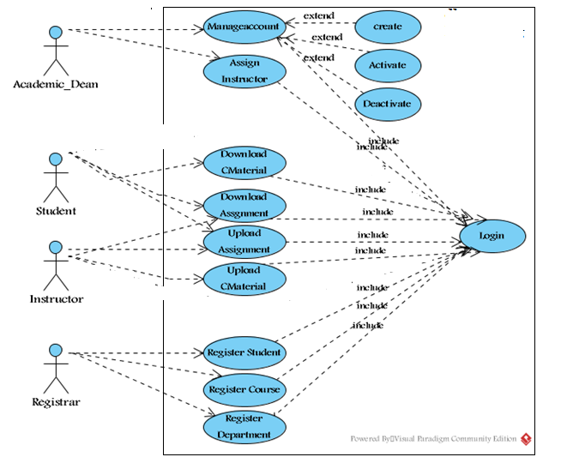

*Fig 2.1 Use case diagram for E-learning system*

|  |  |
| --- | --- |
| Use Case Name | Login |
| **Identifier** | Uc1 |
| **Description** | To authenticate the user |
| **Actor** | Academic-Dean, Registrar-officer, Instructor and student. |
| **Pre-condition** | The user must be registered on the system |
| **Post-condition** | The authenticated user gets the appropriate page. |
| **Basic course of actions** | **Step1**: Select the login link  **Step2:** The system displays the login form  **Step3:** Fill user name and password  **Step4:** systemValidate user name and password.  **Step5:** The system displays the appropriate page. |
| **Alternative course of action** | If the username and password is incorrect  The system displays incorrect user name and password message.  The system redirects to go **step 3** i.e.to enter the username and password |

***Table 2.1*** *description of login use case*

|  |  |
| --- | --- |
| **Use-case name** | **Upload**  Course material |
| **Identifier** | **Uc2** |
| **Description** | **The process will start by activating the system or the window and then home page and the login link also displays.** |
| **Actor** | **Instructor** |
| **Pre-condition** | 1. **the instructor should prepare file to upload** 2. **An instructor should have to enter a valid user name and password.** |
| **Post-condition** | 1. **UploadCourse** material **successfully.** 2. **Finally logout from page** |
| **Basic course of actions** | **Step 1: The** instructor **should clicks on upload** Course material **link.**  **Step 2: instructor should have to click on browse the file button**  **Step 3: browses where the file to be uploaded**  **Step 4: Then** instructor **click on upload button.** |
| **Alternative course of action** | **Step 3: If the size or type of file to be uploaded is out of size, the** instructor**should compress the file.** |

***Table 2.2****Description of upload* Course material *use case.*

|  |  |
| --- | --- |
| **Use-case name** | **download** Course material |
| **Identifier** | **Uc3** |
| **Description** | **The process will start the student by activating the system or the window and the home page and login link will be displayed.** |
| **Actor** | **Student** |
| **Pre-condition** | 1. **There should be uploaded course material.** 2. **Student must insert his/her ID number as user name and password.** |
| **Post-condition** | 1. **Download** Course material **successfully** 2. **Finally logout from the page** |
| **Basic course of actions** | **Step 1:the student should click on download** Course material **link.**  **Step 2:he/she enter course code and course name**  **Step 3:student click on download file button** |
| **Alternative action** | **Step 3: if no uploaded file it shows No file message** |

***Table 2.3****Description of download* Course material *use case.*

|  |  |
| --- | --- |
| **Use-case name** | **Upload assignment** |
| **Identifier** | **Uc4** |
| **Description** | 1. **This process can be performed by instructor as well as by student. An instructor uploads assignment questions for student.** 2. **Student downloads the assignment questions and after completion the student should submit the answers toinstructor.** |
| **Actor 1** | **Instructor** |
| **Actor2** | **Student** |
| **Pre-condition** | **1: An instructor must prepare assignment questions to upload.**  **2: students must do their assignment to submit** |
| **Post-condition** | 1. **The assignment was uploaded successfully.** 2. **Finally logout from the page** |
| **Basic course of actions** | **Step 1: the user click on upload assignment link**  **Step 2:user fillsthe form.**  **Step 3:then he/she press on upload button**  **Step 4: The system should have to check the submission date.** |
| **Alternative course of action** | **Step 4:if submission date has been passed the student cannot upload the assignment so, student must submit on the provided date.** |

***Table 2.4*** *Description of upload assignment use case.*

|  |  |
| --- | --- |
| **Use-case name** | **Download assignment** |
| **Identifier** | **Uc5** |
| **Description** | **This process can be performed by instructor as well as by student.**   1. **An instructor can download assignment answers submitted by student.** 2. **Student can download assignment questions that uploaded by instructor.** |
| **Actor 1** | **Instructor** |
| **Actor2** | **Student** |
| **Pre-condition** | 1. **There should be uploaded assignment questions to students** 2. **There should be submitted assignment for instructor.** |
| **Post-condition** | 1. **The assignment was downloaded successfully.** 2. **Finally logout from the page** |
| **Basic course of actions** | **Step 1: the user click on download assignment link**  **Step 2: user enters course code and course name.**  **Step 3: then user press on download button.** |
| **Alternative course of action** | **Step 3. If no uploaded assignment no file message will be displayed** |

***Table 2.5*** *Description of download assignment use case*

|  |  |
| --- | --- |
| **Use case name** | **Manage user account** |
| **Identifier** | **Uc6** |
| **Description** | 1. **An Academic Dean manages users’ account.** 2. **Updates user account like changing user name and password.** 3. **Academic Dean creates new account for instructors.** |
| **Actor** | **Academic Dean** |
| **Pre-condition** | 1. **An Academic Dean should have to enter a valid user name and password in order to create, update and delete user account.** |
| **Post-condition** | 1. **You update, create and delete user account successfully message will be displayed.** 2. **Finally logout from the page.** |
| **Basic course of actions** | **Step 1. Academic Dean should have to choose account item**  **Step 2. Then click on the selected account item.**  **Step3.The AcademicDean should have to create/activate/deactivate the user’s account.** |
| **Alternative course of action** | **Step 3. Confirmation/rejection message will be displayed.** |

***Table 2.6*** *Description of manage user account use case.*

|  |  |
| --- | --- |
| **Use case name** | **Register student** |
| **Identifier** | **Uc7** |
| **Description** | **Registrar officer registers students who fulfill necessary criteria** |
| **Actor** | **Registrar officer** |
| **Pre-condition** | **1. Registrar officer enter valid user name and pass word to get student registration form.** |
| **Post-condition** | 1. Instructor can access the registered student list 2. **Finally logout from the page** |
| **Basic course of actions** | **Step 1**.The registrar officer fills the basic information of the student.  **Step 2**. After completion of filling the form he/she click on register button.  **Step 3.**If ID repetition occurs the error message will be displayed |
| **Alternative course of action** | **Step 3.If the same id is present on the same academic year the system displays this student already registered message. So the registrar officer must give unique ID for each student on the same academic year.** |

***Table 2.7****Description of register student use case.*

|  |  |
| --- | --- |
| **Use case name** | **Register Course** |
| **Identifier** | **Uc10** |
| **Description** | **Registrar officer registers course (curriculum) of the** University**.** |
| **Actor** | **Registrar officer** |
| **Pre-condition** | **1. Registrar officer enter valid user name and pass word to get course registration form.**  **2. If student is above first year first semester he/she must score promotion gradefor course.BR3** |
| **Post-condition** | 1. **Finally logout from the page** |
| **Basic course of actions** | **Step 1**.The registrar officer fills the basic information of the  Course.  **Step 2**. After completion of filling the form he/she click on register button.  **Step 3.** If course code repetition occurs the error message will be displayed |
| **Alternative course of action** | **Step 3. If the same course code is present the system displays this course already registered message. So the registrar officer must give unique course code for each course.** |

***Table 2.10*** *description for course registration use case*

|  |  |
| --- | --- |
| Use Case Name | Departmentregistration |
| Identifier | Uc11 |
| description | Registrar officer registers the department |
| Actor | Registrar officer |
| precondition | 1. **Registrar officer enter valid user name and pass word to get Department registration link** 2. He/she clicks the link |
| Post condition | 1. Finally logout from the page |
| basic course of action | **Step 1**.The registrar officer fills the name of the Department.  **Step 2**. After filling the name he/she click on register button. |
| Alternative course of action | **Step 3. If not registered correctly system generates error message** |

***Table 2.11*** *description for department registration use case*

# 2.8 Activity diagrams

Activity diagram is another important diagram in UML to describe dynamic aspects of the system. Activity diagram is basically a flow chart to represent the flow form one activity to another activity. The activity can be described as an operation of the system. So the control flow is drawn from one operation to another. This flow can be sequential, branched or concurrent. The following activity diagrams are specified in the new system E-Library Management System.



*Fig 2.2Activity diagram for user login*



*Fig 2.3 Activity diagram for upload* Course material



*Fig 2.4Activity diagram for download* Course material



*Fig 2.5 Activity diagram for upload assignment*



*Fig 2.6 Activity diagram for download assignment*

**

*Fig 2.9 Activity diagram for register student*



*Fig 2.10Activity diagram for manage account*

# 2.9Sequence diagram

A sequence diagram links use case with objects. It shows the interaction between participating objects in a given use case. It is helpful to identify the missing objects that are not identified in the analysis object model.



*Fig 2.11 Sequence diagram for login*



Fig 2.12 Sequence diagram for upload Course material



*Fig 2.13Sequence diagram for download* Course material

*Fig 2.14 Sequence diagram for upload assignment*



*Fig 2.15Sequence diagram for download assignment*



*Fig 2.18Sequence diagram for student registration*



*Fig 2.19 course registration*



*Fig 2.20 semester registration*

# 2.10 Collaboration Diagram

Collaboration diagram is another form of interaction diagram. It represents the structural organization of a system and the messages sent/received. Structural organization consists of objects and links.

The purpose of collaboration diagram is similar to sequence diagram. But the specific purpose collaboration diagram is tovisualize the organization of objects and their interaction.



*Fig 2.21Collaboration diagram for user login*



*Fig 2.22Collaboration diagram for upload* Course material



*Fig 2.23 Collaboration diagram for upload assignment*



*Fig 2.24 Collaboration diagram for download course material*



*Fig 2.25Collaboration diagram for download assignment*



*Fig 2.28Collaboration diagram for student registration*



*Fig 2.29 collaboration diagram for course registration*

# 2.11State chart diagram

State-chart diagram describes the flow of control from one state to another state. States are defined as a condition in which an object exists and it changes when some event is triggered. So the most important purpose of State-chart diagram is to model life time of an object from creation to termination.

The main purposes of using State-chart diagrams are:

* To model dynamic aspect of a system
* To model life time of a reactive system
* To describe different states of an object during its life time
* Define a state machine to model states of an object



*Fig 2.30State chart diagram for Login*



*Fig 2.31State chart diagram for upload* Course material



*Fig 2.32State chart diagram for download* Course material



*Fig 2.33State chart diagram for upload assignment*



*Fig 2.34State chart diagram for download assignment*



*Fig 2.37State chart diagram for student registration*

# Analysis class diagram

Class diagram is static model that shows the classes and the relationships among classes that remain constant over the time. Class is the main building block of class diagram, which stores and manages information in the system. In the phase of conceptual class modeling we just create or classes ad their interrelationship**. Identified classes are shown in Fig 2.34.**



*Fig 2.38 analysis class diagram*

# CHAPTER THREE

# 3 System Design

# 3.1 Introduction

**System design is the transformation of the analysis model into a system design model. System design is the first part to get into the solution domain in a software development. This chapter focuses on transforming the analysis model into the design model that takes into account the nonfunctional requirements and constraints described in the problem statement and requirement analysis sections discussed earlier.**

# 3.2 Design goals

The objectives of design are to model the system with high quality. The design goals are derived from non-functional requirements that means non-functional requirement is the description of the feature characteristics and attribute of the system as well as any constraints that may limit the boundary of the proposed solution.

Design goals describe the qualities of the system that the developers should consider.

* **Fault Tolerance**E-Library Management Systemshould be fault tolerant to loss of connectivity with the service.
* **Security:**for our system we use strong password inorder to secure the system.
* **Modifiability: -**E-Library Management Systemshould be modifiable for further modification and enhancement of the application.
* **Performance**: - E-Library Management Systemshould respond fast with high throughput, i.e. it should perform the task quickly as possible such as upload and download Course material and assignments.
* **Cost**: The system should be developed with minimum cost possible.
* **End User Criteria**: - The system should have simple and understandable graphical user Interface such as forms and buttons, which have descriptive names.

# 3.3 System Decomposition

In order to simplify and minimize the complexity of the solution domain, our system has been divided into three subsystems. These are learning subsystem, registering Subsystem and Administration subsystems. The decomposition of the system is represented in the Figure below.

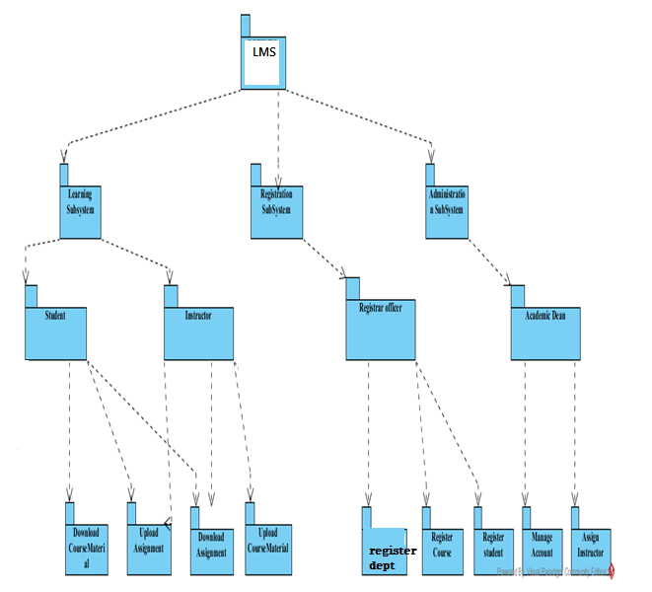

*Fig 3.1 system decomposition*

**Learning Subsystem**

The learning subsystem is responsible for providing education service. This service is for both instructor to student and student to instructor interaction.

The student class is responsible for providing students information and instructor class is for providing instructor information.

**Administration Subsystem**

This subsystem enables the **Academic Dean** to manage user accounts. The management includes creation of new accounts, removing the existing accounts and modification of accounts. The management of user account is the responsibility of the account class. The account class is the one that creates displays and modify the user account.

**Registration subsystem**

This subsystem enables the registrar officer to register student’s information and course information. The registering of student’s information is the responsibility of the registrar class and registering of course information is also course class.

# 3.4 Design level class diagram

The class diagram is a static diagram. It represents the static view of an application. Class diagram is not only used for visualizing, describing and documenting different aspects of a system but also for constructing executable code of the software application.

The class diagram describes the attributes and operations of a class and also the constraints imposed on the system. The classes diagrams are widely used in the modeling of object oriented systems because they are the only UML diagrams which can be mapped directly with object oriented languages. The class diagram shows a collection of classes, interfaces, associations, collaborations and constraints. It is also known as a *structural diagram*.



*Fig 3.2 Design class diagram*

# 3.5Database design

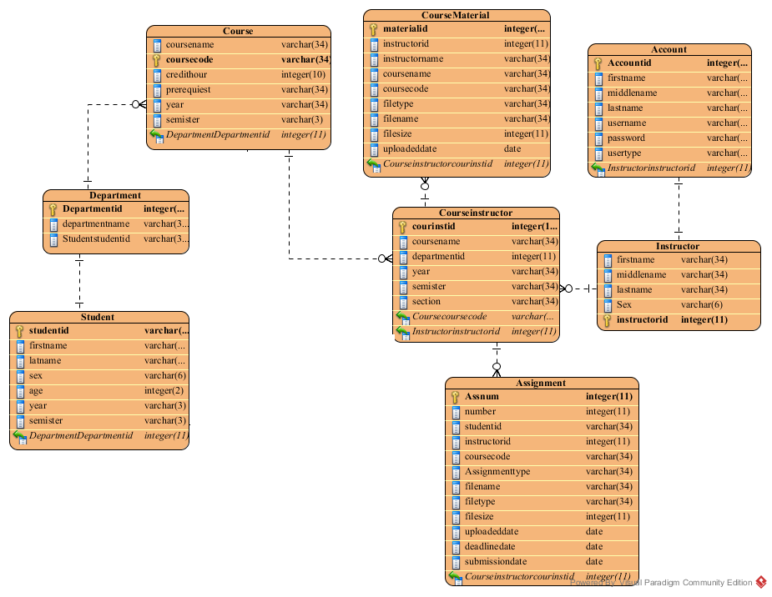

*Fig 3.3database design*

# CHAPTER FOUR

# 4 Implementation Deliverable of the New System

# 4.1 Component diagram

In this Diagram components of the system will be wired showing that there is relation among components, management of the system, database and operations performed on databases such security issue. This in some extent shows which component or objects will be accessed by whom and what type of security infrastructures it is using. The diagram is simulated below.

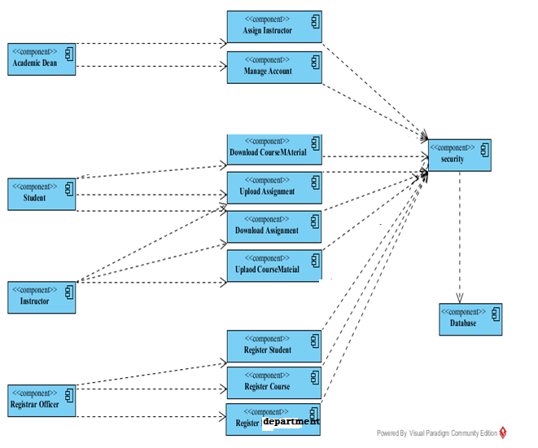

Fig 4.1*Component diagram*

# 4.2 Deployment diagram

The name Deployment itself describes the purpose of the diagram. Deployment diagrams are used for describing the hardware components where software components are deployed. Component diagrams and deployment diagrams are closely related.

Component diagrams are used to describe the components and deployment diagrams shows how they are deployed in hardware.

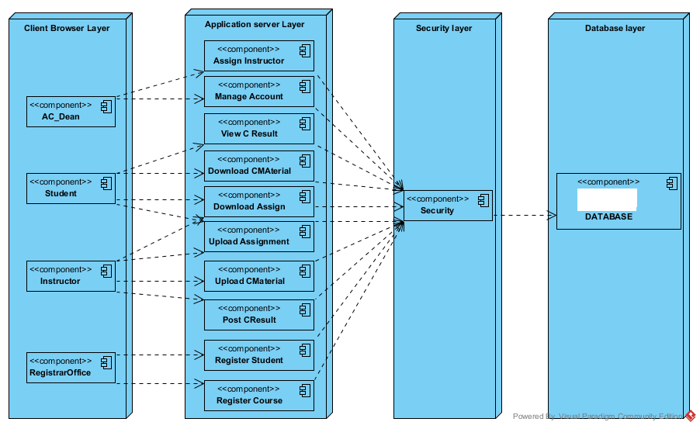

*Fig 4.2 deployment diagram*

# 4.3 User Interface

In this system users will communicate with it through the following user interfaces.

1. **Home Page:** This form contains some links which lead it to the concerned page, and if the user has an account he/she will directly go to concerned page by entering their username and password.

# CHAPTER SIX

# 6.1Conclusion and Recommendation

The development and advancement of computer technology makes computers to be a part of everyday human life activities. Education is an area where the human is involved in a day to day activity of his life. It is an area which requires due attention, for it deals with behavioral, attitude and skill changes. The same is true for the use of computer in education. This project has enabled the delivery of learning materials to be efficient and it has also achieved interactivity among students and instructors. This project is going to develop using the PHP web technology. This technology choice has enabled the work to have portability, extendibility and security. The portability enables the work to be deployed on a given platform. The extendibility can be expressed as features for the work to tolerate the future expansions on the area. The security features of the PHP language can be incorporated to the level of requirement in need.

The system that we have tried to develop is not the whole system of the University .Because of time limitation and budget we can’t develop all parts of the system, but we have tried to automate some sub systems and functionalities. The following functionalities can’t be automated because of the limitations that we have discussed above.

* **Online examination**
* **Online CGPA of the students.**
* Online registration

**Therefore, others who are interested to develop on this e-learning system of the** University **can get some initial idea about the system will improve the system.**

**User interface**

